**Programming Fundamentals**

**CSC103**

**Assignment # 04**

|  |  |
| --- | --- |
| Name | Syeda Mayyam Fatima Sohail |
| Registration Number | FA’23-BCE-107 |
| Class | Programming Fundamentals |
| Instructor’s Name | Dr. Babar Mansoor |

**Question 01:**

1. Write a C language program to delete a word from a string. Both the string and the word to be deleted are input by the user. Note that the word may appear any number of times.

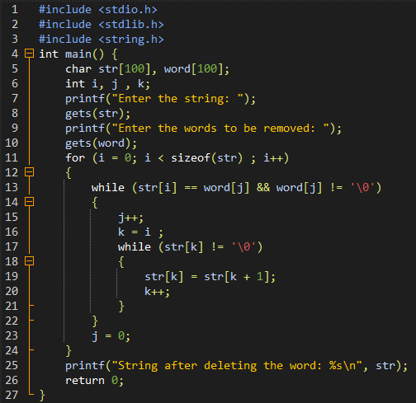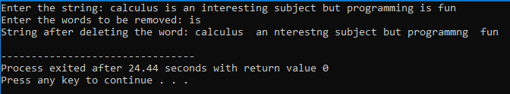

**Critical Analysis:** This program teaches us how to enter a string and remove words/elements from it.

1. Write a C program that will analyze a line of text and will print the number of words, the number of consonants, and the number of vowels in the text.

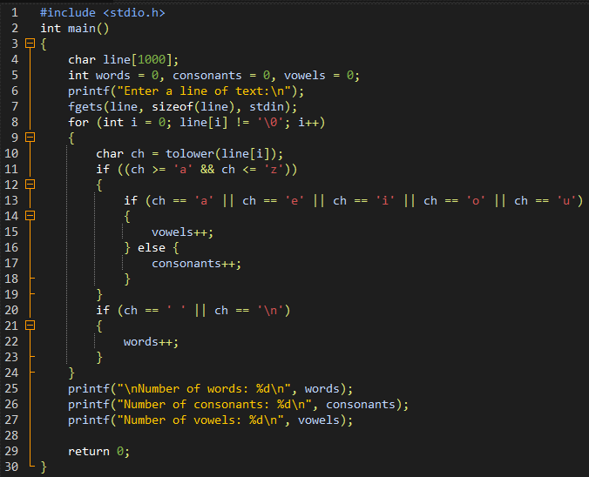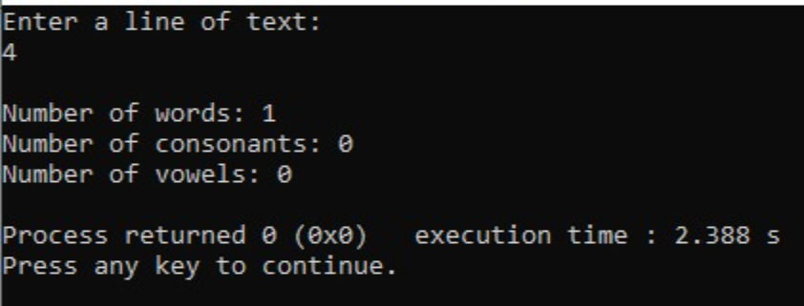

1. Write a C program that reads a line of text and counts all occurrences of a particular word.

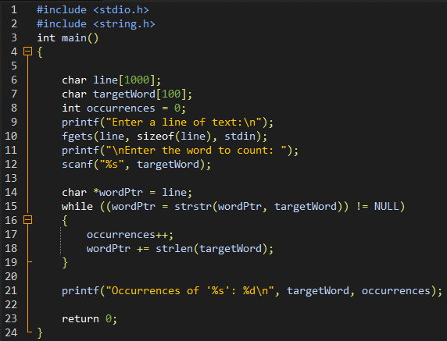

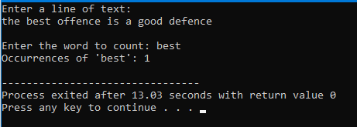

**Critical Analysis:** This program teaches us how to count the occurrences of a word in a string.

1. Write a program to convert each character of a string into the next alphabet and print the string.

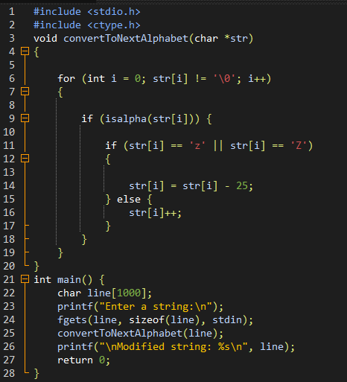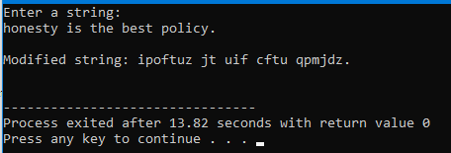

**Critical Analysis:** This program teaches us how to convert each character of a string into the next alphabet.

**Question 02:**

Write a C program that accepts a word from the user and prints it in the following way.

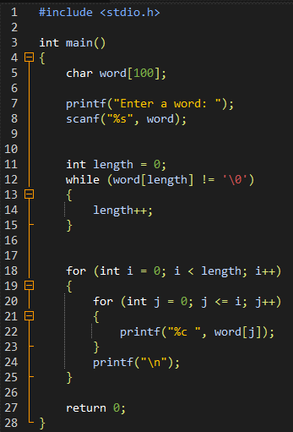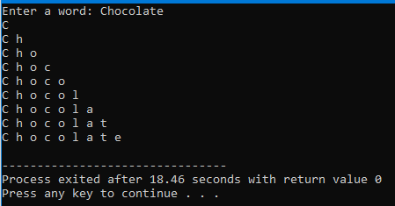

**Critical Analysis:** This program helps us learn how to print a word in a way that it makes a 90 degree angle.